Discovery Session with SupplierName
Suggestions: (1) Update the light blue fields (using black text) once per project. (2) Update the CustomerName fields (using black text) for each interview candidate. (3) Delete this text box. (4) E-mail this to customer contact prior to, during, or just after phone call used to set up interview. (5) Tell customer contact they can fill in the Date/Time & Location fields and use this sheet to invite their colleagues.
Description & Agenda

Date/Time: TBD

Location: TBD

Purpose: SupplierName wants to bring fresh innovation to MarketSegment/ProjectScope. The sole purpose of this meeting is for them to hear what is important to CustomerName … before SupplierName develops any new technology for this area.

What This is Not:
- Sales pitch: No attempts to sell anything.
- Problem-solving: No solution-seeking or sharing of confidential information.
- Survey: No filling the blanks in a questionnaire.

What This Will Look Like:
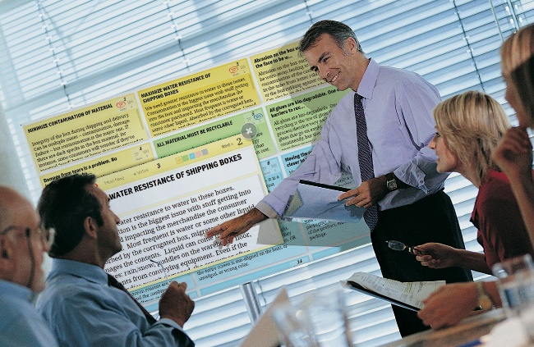
- SupplierName will send 2 or 3 technical and commercial people… to listen.
- Notes will be projected—to make sure they’re correct.
- CustomerName can get a copy of these notes later if desired.
- SupplierName will facilitate, using proven “New Product Blueprinting”¹ methods.
- Discussions will center on whatever CustomerName deems important.

Attendees: The scope will be MarketSegment/ProjectScope… so it will help to have all interested disciplines at the session, e.g. technical, production, marketing, etc.

Agenda: The real “agenda” is whatever CustomerName would like a committed supplier to know about its needs. But the flow of the meeting is typically:

- Current State… just two or three questions to help ground SupplierName.
- Problems… challenges, difficulties or obstacles now faced by CustomerName.
- Ideal State… what a “perfect world” would look like.
- Triggered Ideas… helpful tools will be introduced that may trigger more ideas.
- Top Picks… CustomerName will have the chance to identify its favorite ideas.

Questions?: If you have any questions, please contact SupplierContactName, SupplierContactTitle, at SupplierContactEmail or SupplierContactPhone. Also, many of your questions can be answered at www.HaveYouBeenDiscovered.com.

¹ “Blueprinting” is used for intelligent, peer-to-peer B2B meetings--not consumer surveys. Info is at www.newproductblueprinting.com.

